Identifying Key Drivers of NFL Team Success: A Multivariate Regression Approach
Robert (Bo) Emory
Oklahoma State University, Spears School of Business, Stillwater, Oklahoma 74077
remory@okstate.edu
Bo is a master's student in Business Analytics and Data Science with a background in mathematics and computer science. His main area of focus is sports analytics and predictive modeling to improve the sports industry from injury risks to financial decisions.
Chase Wolters
Oklahoma State University, Spears School of Business, Stillwater, Oklahoma 74077
chase.wolters@okstate.edu
Chase is a master's student in Business Analytics and Data Science with a background in accounting and financial markets. His research focuses on applying machine learning techniques to uncover meaningful patterns in health analytics, finance, and sports.
Abstract: Understanding what factors drive NFL team success remains a complex challenge due to the numerous factors that influence performance throughout the season. This study explores the impact of various factors including preseason roster changes, draft picks, salary cap allocations, and in-game performance statistics to develop a predictive model for team success. Using a stepwise linear regression model, this research seeks to identify which factors most significantly impact a team's in-season success, providing valuable insights for team management and strategic decision-making. To achieve this, data has been collected from Pro Football Reference and Spotrac, integrating historical team performance metrics with financial and personnel-related variables. Following the CRISP-DM framework, the study involves extensive data preparation, feature engineering, and statistical analysis to ensure model robustness and interpretability. Preliminary results suggest that a combination of roster stability, salary cap efficiency, and in-game efficiency metrics (such as turnover margin) are among the strongest predictors of team performance. This research contributes to the growing field of sports analytics by offering data-driven insights into what drives success in the NFL, with practical implications for team executives, analysts, and sports bettors seeking a deeper understanding of team performance drivers. By leveraging predictive modeling, this study enhances the understanding of which factors influence NFL team success.

I. Introduction and Overview of Research Question

A. Introduction to Research
Predicting NFL team success is a complex and widely debated challenge in sports analytics. While expert opinions, qualitative assessments, and historical win-loss records have traditionally guided expectations, these methods often lack objectivity and fail to capture the multifaceted nature of team performance. In recent years, the growing availability of structured data and the advancement of analytical techniques have opened the door to more rigorous, data-driven approaches for understanding what truly drives team success.
In professional football, regular-season performance is shaped by a dynamic combination of factors including preseason expectations, in-game execution, coaching stability, salary cap strategy, and roster continuity. While some franchises maintain consistent performance through strong leadership and operational efficiency, others experience dramatic year-to-year fluctuations due to injuries, trades, or mid-season adjustments. A holistic analysis of these variables both before and during the season, can yield valuable insights for strategic planning, personnel decisions, and competitive benchmarking.
This study aims to quantify the influence of various preseason, financial, coaching, and in-game performance variables on a team's regular-season win total. Using data from Pro Football Reference and Spotrac, we incorporate a broad range of features including player metrics, coaching changes, salary allocations, and key performance indicators like turnover differential and third-down efficiency. By applying a stepwise linear regression approach, we identify the most significant factors contributing to team success, balancing model accuracy with interpretability.
Stepwise regression, a variable selection method that iteratively adds or removes predictors based on statistical significance, is well-suited for isolating impactful features from a large set of potential drivers. This approach enhances model transparency and supports more actionable insights. Ultimately, this research offers a comprehensive, data-driven perspective on what influences winning in the NFL, with practical implications for team executives, analysts, and fans seeking to better understand the anatomy of a successful season.

B. Research Question
This study seeks to answer the following key research questions:
- What are the most significant factors across preseason expectations, financial metrics, coaching decisions, and in-game performance that influence an NFL team’s regular-season win total?
- Can stepwise linear regression effectively identify and prioritize the variables that contribute most to team success?
- How do financial, coaching, and performance-based variables interact to explain variation in team outcomes?
These questions aim to establish a data-driven framework for evaluating NFL team performance, moving beyond intuition-based predictions toward a more objective understanding of what impacts winning in professional football.

C. Variables and Data Description/Preparations
This study utilizes a comprehensive dataset compiled from Pro Football Reference and Spotrac, two widely recognized sources for historical team performance and financial data in the NFL. Pro Football Reference provides detailed statistical records, including team performance metrics such as win percentage, point differentials, and strength of schedule, while Spotrac offers salary cap information, contract details, and financial allocations for each team. The dataset includes 10 seasons (2014-2024) of NFL team data, capturing key preseason variables such as roster stability (number of returning starters, player acquisitions, and losses), draft pick efficiency (number of draft picks and rookie contributions), coaching changes, and salary cap distributions (allocation of spending across current players and new acquisitions). By integrating data from these two sources, the study ensures a robust and reliable foundation for predictive modeling.

Data Preparations
The data preparation process involved combining multiple datasets from different sources to create a unified, structured dataset suitable for analysis. These datasets were joined using a composite key based on team name and season, allowing for seamless alignment across the various data domains.
To ensure consistency and completeness across seasons, we focused on a 10-year period from 2014 to 2024. Most datasets contained full information for this timeframe; however, one notable exception was the NewStarter dataset, which includes data only for the 2015 to 2023 seasons. For seasons where this data was unavailable, the variable was left as null.
Handling missing values was a critical step in preparing the data for analysis. Null values were addressed using a combination of strategies. For numerical variables with sporadic missing entries, we applied mean imputation to preserve the overall distribution without introducing extreme values. In cases where missing values represented a meaningful absence (e.g., no new starters data for a given season), the nulls were retained to avoid making assumptions that could distort the model.
Additional preprocessing steps included renaming variables for clarity, standardizing team names across datasets to ensure accurate joins, and encoding categorical variables where necessary.
The resulting dataset provided a comprehensive view of NFL team dynamics across seasons, serving as a solid foundation for the subsequent statistical modeling and analysis.

Data Description:
Our final dataset consisted of 49 columns and 352 rows spanning a 10-year period from the start of the 2014 NFL season to the conclusion of the 2024 season.
Below is a list of variables used in this analysis:

Dependent Variable (Response Variable):
- Team Wins in a season (W): A continuous variable indicating the total number of regular season games won by an NFL team in a given season.

Independent Variables (Predictors):
- Historical Performance Metrics:
  - Points For (PF): (Continuous) Points scored by team.
  - Points Against (PA): (Continuous) Points scored by opposition.
  - Point Differential (PD): (Continuous) Difference between points scored by team and points scored by opposition.
  - Strength of Schedule (SoS): (Continuous) Average quality of opponent as measured by SRS
  - Simple Rating System (SRS): Team quality relative to average (0.0)
  - Offensive SRS (OSRS): Team offense quality relative to average (0.0)
  - Defensive SRS (DSRS): Team defense quality relative to average (0.0)
  - Total_yds: Total number of yards a team gets throughout the entire season
  - Plays: (Continuous) Offensive Plays: Pass Attempts + Rush Attempts + Times Sacked
  - Yds/Play: (Continuous) Yards per Offensive Play (Rush + Pass Yards)/(Pass Attempts + Rush Attempts + Times sacked)
  - TurnOvers: (Continuous) Team Turnovers lost
  - FumblesLost: (Continuous) Fumbles Lost by player of team
  - Passes_Completed: (Continuous) Passes Completed
  - Passing_Att: (Continuous) Passes Attempted
  - Passing_Yds: (Continuous) Yards Gained by Passing for teams, sack yardage is deducted from this total
  - Passing_TD: (Continuous) Number of passing touchdowns
  - Passing_Int: (Continuous) Number of interceptions thrown
  - Passing_NetYds/A: (Continuous) Net Yards gained per pass attempt (Passing Yards – Sack Yards)/(Passes Attempted + times Sacked)
  - Passing_1stDowns: (Continuous) First Downs by passing
  - Rushing_Att: (Continuous) Rushing Attempts (Sacks not included)
  - Rushing_Yds: (Continuous) Rushing Yards Gained (Sack yards not included)
  - Rushing_TD: (Continuous) Number of Rushing Touchdowns
  - Rushing_Y/A: (Continuous) Rushing Yards per Attempt
  - Rushing_1stDowns: (Continuous) First Downs by Rushing
  - Penalties: (Continuous) Number of penalties committed by team and accepted
  - Penalties_Yds: (Continuous) Number of Penalties in yards committed by team
  - 1stDowns/Penalty: (Continuous) First Downs by Penalty
  - %Drives_ending_inOScore: Percentage of drives ending in an offensive score
  - %Drives_ending_inTO: Percentage of drives ending in an offensive turnover
- Roster Stability:
  - NewStarters: (Continuous) Number of new starters at the start of the current season compared to last season
- Salary Cap Allocations:
  - Free Agents: (Continuous) Amount of money spent ($) on signing new free agent contracts
  - Extensions: (Continuous) Amount of money spent ($) on signing contract extensions to retain current players
  - Draft Picks: (Continuous) Amount of money spent ($) on new rookie (draft) contracts
  - Tags: (Continuous) Amount of money spend ($) when franchise tagging a player
  - Restricted Tender: (Continuous) Amount of money spent ($) signing restricted free agent players
  - Undrafted: (Continuous) Amount of money spent ($) signing undrafted free agent players
  - Total_Spending: (Continuous) Total Amount of money ($) a team spends on their roster for the current season

D. Rationale
- The NFL’s salary cap structure, coaching turnover, and player performance variability create a highly dynamic environment where team success depends on a complex interplay of factors across and within seasons.
- Teams, analysts, and decision-makers increasingly seek quantitative methods to better understand which variables, ranging from roster investments to in-game efficiency, create consistent wins.
- A data-driven approach leveraging statistical modeling can support more informed decision-making for general managers, analysts, and even sports bettors by identifying patterns linked to on-field success.
- Stepwise linear regression offers a practical and interpretable method for identifying the most impactful variables by iteratively selecting predictors with statistically significant influence on regular season win totals.

II. Statistical Analysis

A. Descriptive Statistics Overview
To begin the analysis, descriptive statistics were calculated for all relevant variables to understand the overall distribution and central tendencies within the dataset (See Appendix). Summary metrics such as the mean, median, standard deviation, minimum, and maximum values were computed for continuous variables (see below), including team wins, salary cap spending, offensive performance metrics, and roster turnover. In addition to numerical summaries, various exploratory data analysis (EDA) techniques were employed to better understand relationships and distribution patterns across variables. A correlation matrix was used to examine Pearson correlation coefficients between continuous predictors and team win totals, helping to identify potential linear relationships. Histograms and boxplots were created to visualize the spread and skewness of key variables, while scatterplots were used to explore possible associations and trends between predictor variables and team success (See Appendix).
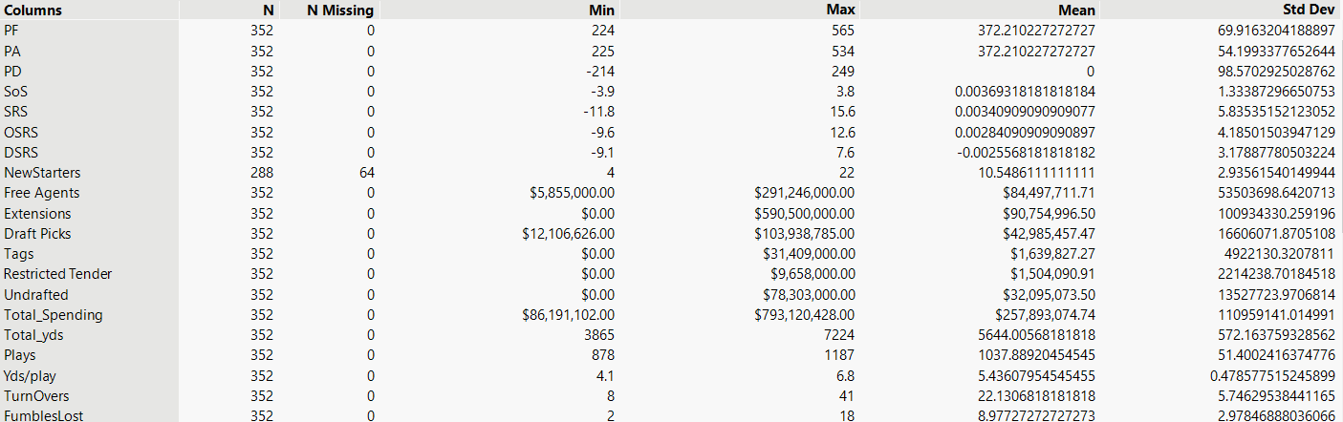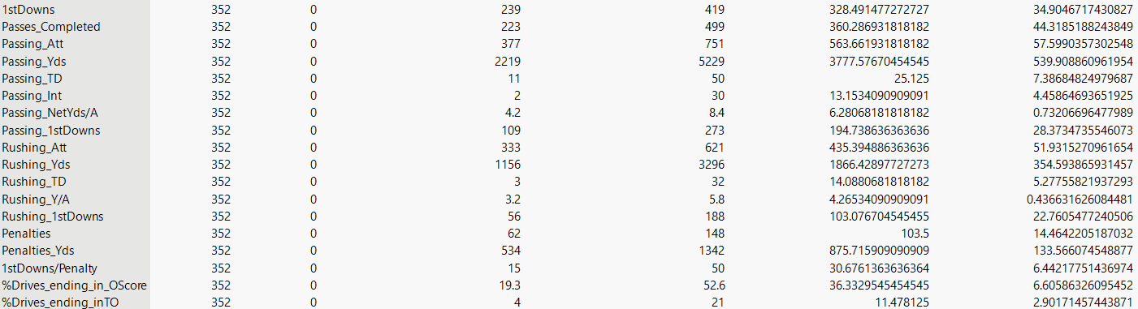

B. Stepwise Linear Regression Methodology
For this analysis, we selected stepwise linear regression due to its effectiveness in handling models with a large number of potential predictors. Stepwise linear regression models systematically evaluate the statistical significance of each variable, which allows the model to retain only those variables that meaningfully contribute to predicting team success while filtering out less impactful or redundant factors. Stepwise regression is particularly valuable in sports analytics, where variables can be highly correlated or overlapping in influence.
We employed bidirectional (mixed) elimination, which combines both forward selection and backward elimination techniques to iteratively add or remove variables based on their statistical significance. Specifically, we used an entrance p-value threshold of 0.10 and an exit threshold of 0.05 to determine which variables were included or excluded from the model. This approach ensured that only predictors with meaningful explanatory power were retained while minimizing the risk of overfitting. The final model aimed to be both statistically robust and interpretable.
All statistical modeling and diagnostics were conducted using JMP statistical software, which provided an interactive environment for managing data, performing regression analysis, and assessing model assumptions. Prior to modeling, we evaluated multicollinearity using Variance Inflation Factor (VIF) values. Variables with high VIF scores were considered for removal or transformation to maintain model stability. We also assessed the key assumptions of linear regression including linearity, independence of residuals, homoscedasticity, and normality using diagnostic tools such as residual vs. fitted plots, Q-Q plots, and the Durbin-Watson test (See Appendix).
Model performance was evaluated using R-squared, adjusted R-squared, and Root Mean Squared Error (RMSE) to determine how well the selected predictors explained variation in team win totals. Residual analysis was also conducted to verify the adequacy of the model fit and to identify any influential observations or outliers.
Overall, this statistical approach provided a rigorous and transparent framework for identifying the most impactful preseason, financial, coaching, and in-game factors influencing NFL team performance throughout the regular season.

III. Interpretation of Results
In this section, we evaluate the results of our stepwise linear regression model and provide interpretations of the key predictors identified. By examining the direction, magnitude, and significance of each variable’s coefficient, we aim to understand how various preseason, financial, coaching, and in-game factors contribute to regular-season success in the NFL.

A. Findings from Descriptive Statistics
The exploratory analysis revealed several strong predictors of team success. Point Differential (r = 0.83) and Points For (r = 0.77) had the strongest positive correlations with wins. This was supported by clear upward trends in scatterplots (See Appendix). Composite strength metrics such as SRS, OSRS, and DSRS also showed strong relationships with win totals, which indicates value in evaluating overall team performance. Key efficiency metrics, including Passing Net Yards per Attempt and Yards per Play, were positively associated with winning, suggesting that offensive efficiency matters more than total volume. Additionally, fewer turnovers and the percentage of drives ending in turnovers were strongly associated with more wins based on scatterplots and correlation matrix. This tells us that ball security could play an important role in overall team success. In contrast, financial variables like total spending, free agent contracts, and extensions showed little to no correlation with team success. These findings helped focus the model on the most impactful performance-based predictors.

B. Stepwise Regression Results
The stepwise linear regression model identified several statistically significant predictors of regular season wins. Point Differential (PD) was found to be the most influential factor (p < 0.0001). For every additional point in PD, a team's expected win total increases by approximately 0.025 games. This highlights the importance of outscoring opponents across the season. Other meaningful predictors were Rushing Yards per Attempt (Rushing_Y/A), which showed a negative relationship suggesting that higher rushing efficiency alone may not directly translate to more wins, potentially due to context-dependent play-calling. Rushing Attempts had a small but positive effect, while a higher percentage of drives ending in turnovers significantly reduced win totals. Lastly, expected points contributed by offense (Pts_EXP_byOffense) also had a modest positive impact.
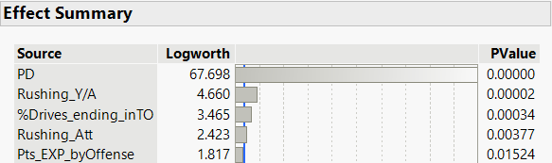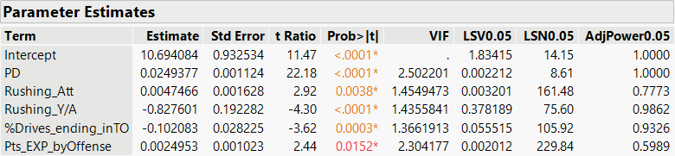

In terms of model performance, the regression model explained approximately 82.4% of the variation in team wins (Adjusted R² = 0.824), indicating strong predictive capability, when accounting for the large number of variables. The Root Mean Squared Error (RMSE) of 1.31 suggests the model’s average prediction error is just over one win per team, which we believe is acceptable for season level forecasting. Residual analysis confirmed that the assumptions of linear regression were reasonably met, with no clear evidence of heteroscedasticity or non-normality in residual plots (See Appendix). Additionally, variance inflation factors (VIFs) were all below 2.6, indicating that multicollinearity was not a concern. Overall, the model performed well and successfully isolated key performance metrics that drive team success during the NFL regular season.

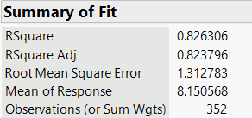

IV. Conclusion and Discussion

A. Summary of Key Findings
The stepwise linear regression model revealed several statistically significant predictors of NFL team success, with Point Differential (PD) emerging as the most impactful factor. However, one of the most insightful findings was the contrasting relationship between rushing efficiency and rushing volume. Specifically, the model showed that rushing attempts had a positive effect on win totals, while rushing yards per attempt (Y/A) had a negative relationship with team success.

This contrast suggests that the volume of rushing plays may be a more meaningful indicator of success than rushing explosiveness. One explanation is that teams with a lead often shift toward run-heavy play-calling to manage the clock, preserve possession, and limit the opponent’s opportunities. In this context, high rushing attempts may reflect not only offensive strategy but game flow and control as winning teams tend to run more because they are ahead, not necessarily because the run game is efficient on a per play basis.

Meanwhile, high rushing efficiency (Y/A) may reflect sporadic big plays rather than sustained offensive success. Teams with high Y/A but lower win totals may be relying on inconsistent or boom-or-bust rushing plays, which can boost the stat sheet without providing the drive-sustaining consistency needed to secure victories. This insight reinforces the importance of contextualizing stats rather than interpreting them in isolation.

Other key findings included a negative relationship between turnover percentage and wins, emphasizing the value of ball security, and a modest but significant positive impact from expected points contributed by the offense. Together, these results support a broader takeaway: teams that emphasize sustained drives, control of possession, and mistake free execution are more likely to succeed across the regular season.

B. Practical Implications
For Team Executives:
The results of this study provide actionable insights for NFL front offices. Predictive modeling highlights which player and team attributes are most likely to contribute to winning, offering valuable input into contract negotiations, draft strategies, and player retention decisions. Rather than focusing heavily on high-dollar acquisitions or volume stats, front offices can prioritize players who contribute to efficient offense, limit turnovers, and maintain drive consistency. This approach supports more cost-effective and performance-driven roster construction.

For Analysts and Bettors:
Sports analysts and betting markets can use these findings to refine preseason models and projections. Metrics such as point differential, drive success rate, and rushing efficiency offer stronger predictive value than traditional stats like passing yards or spending. By incorporating these into betting strategies and preseason evaluations, analysts can move away from narrative-based assumptions and toward more evidence-based and data-driven predictions.

C. Recommendations
Based on the model’s results, teams aiming to increase their playoff chances should focus on improving the core drivers of success: scoring margin, offensive efficiency, and turnover minimization. Coaching staff should emphasize play-calling and execution strategies that promote consistency on offense while limiting mistakes particularly in high-leverage moments such as red-zone drives and third downs.
From a personnel perspective, teams should resist overreliance on free agency spending and instead invest in player development, draft value, and roster continuity. Prioritizing versatile players who contribute to efficient yardage gains and situational success can lead to better on-field results at lower cost. Additionally, minimizing disruptive coaching changes and building long-term systems can create the organizational stability needed for sustained playoff contention.

D. Limitations and Future Research
Limitations:
As with any research project, this study faced a few limitations. One primary challenge was the availability and consistency of data for certain variables. For example, while Pro Football Reference provides extensive team data, compiling a complete and standardized list of offensive and defensive coordinators across all teams proved difficult due to inconsistent reporting and frequent coaching changes.

Another limitation involved potential bias in some historical records. Specifically, we considered analyzing the quality of free agent signings and draft picks; however, rankings of NFL prospects and free agents are often subjective, relying on journalist and analyst evaluations. Incorporating these variables could introduce bias, making it difficult to objectively assess their impact on team success.

Future Research:
These limitations open the door for several future research directions. One improvement would be to evaluate roster turnover by position group (e.g., offensive line, secondary) rather than just total new starters. This granularity could reveal which units are most sensitive to changes and how positional stability impacts success.

Another opportunity lies in enhancing financial analysis. Instead of using total spending amounts, future models could focus on the first-year salary cap hit of player contracts. For example, distinguishing between a $15 million/year contract and a $45 million multi-year deal with only partial guarantees could provide more insight into short-term investment efficiency.

Lastly, applying alternative modeling techniques, such as random forests, gradient boosting, or ensemble models could help capture nonlinear relationships and improve prediction accuracy, particularly for teams with outlier seasons.

V. References
Jianakoplos, Nancy Ammon, and Martin Shields. “Practice or profits.” Journal of Sports Economics, vol. 13, no. 4, 22 June 2012, pp. 451–465, https://doi.org/10.1177/1527002512450267.
Pitts, Joshua D. “Determinants of success in the National Football League’s postseason.” Journal of Sports Economics, vol. 17, no. 1, 4 Mar. 2014, pp. 86–111, https://doi.org/10.1177/1527002514525409.
“Pro Football Stats, History, Scores, Standings, Playoffs, Schedule & Records.” Pro, www.pro-football-reference.com/. Accessed 26 Feb. 2025.
Roach, Michael A. “Managerial background, resource allocation, and team performance in the National Football League.” Applied Economics, vol. 56, no. 56, 28 Nov. 2023, pp. 7517–7529, https://doi.org/10.1080/00036846.2023.2288036.
Spotrac. “2024 NFL Offseason.” Spotrac.Com, www.spotrac.com/nfl/offseason/_/year/2024. Accessed 23 Feb. 2025.

Appendix
